Delete a User Role
Story: As an Administrator, I want to Delete a User Role.
Pre-Conditions:
- A User Role is selected.
Workflow:
A User Role selected
User Role Disabled successfully
Initialize Disable function
Confirm to Disable
Scenario
- A User Role selected
- Administrator initializes to Delete
- Administrator confirms to Delete
Storyboard Images:
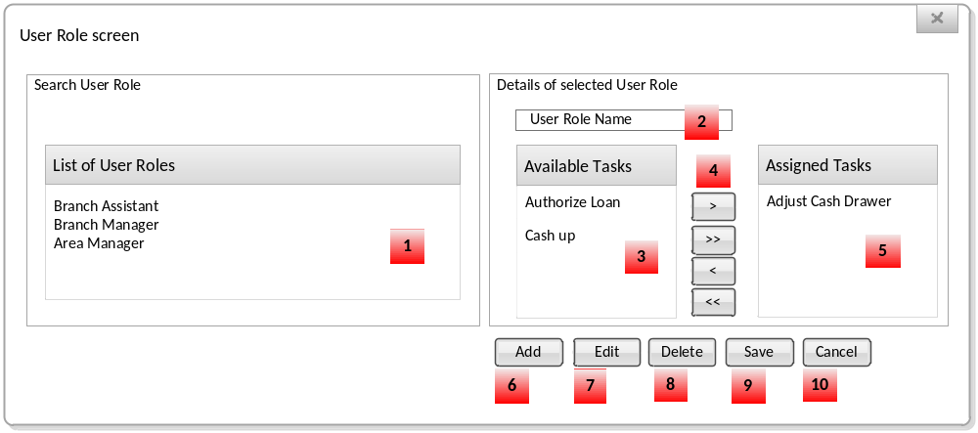

Requirements:
Image Reference | Requirement | Step in Scenario
 | NFR027 – NFR035: Reference to GUI transformation

Post-Conditions:
- Selected User Role is marked as Deleted.

Acceptance Criteria
Test | Expected Result
Test to determine if the successfully Deleted entry | It does not exist in Search Results anymore, and its links with Assigned items do not exist anymore.
Test to determine if the unsuccessfully Deleted entry | It is still exists in Search Results together with Assigned items.
Test to determine if the Confirmation message appears | The Confirmation message appears.  Do you want to delete this User Role?
Test to determine if [No] is selected from Confirmation message, entry is not removed | It still exists in Search Results together with Assigned items.

